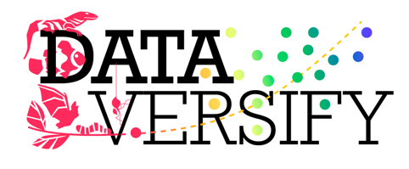 | Sharing Scientist Role Model Stories to Improve Equity and Success in Undergraduate STEM Education

The Biology Education Research team at Auburn University seeks 1-2 full-time quantitative postdoctoral researcher(s) to collaborate on a number of projects related to undergraduate education. The successful candidate will be advised by Dr. Cissy Ballen (ballenlab.com) and will be part of NSF-funded projects through the Improving Undergraduate STEM Education (IUSE) program. The candidate will join a vibrant team spanning Auburn University and Michigan State University (PI Liz Schultheis) to address several research questions related to undergraduate biology education, role models, how ideological bias impacts science, and other influences on student experiences in biology and STEM. Additionally, the successful applicant will be encouraged to develop projects based on their own interests and collaborate with others in the lab and the IUSE research team:
Cissy Ballen, Associate Professor, Department of Biological Sciences, Auburn University
Robin Costello, Assistant Professor, Department of Biological Sciences, University at Buffalo
Melissa Kjelvik, Research Specialist, Michigan State University, MSU
Elizabeth Schultheis, Education & Outreach Coordinator, Kellogg Biological Station LTER, MSU
Marjorie Weber, Associate Professor, Ecology & Evolutionary Biology, University of Michigan
Carolyn Graham, Graduate Student, Ecology & Evolutionary Biology, University of Michigan
Requested Qualifications
- The position requires either a PhD in a Biology/STEM field with a demonstrated interest in science education or other related field.
- Candidates should have experience with study design development, evidence of scholarly writing skills, and the ability to work well as part of a highly collaborative team.
- Preference for this position will be given to applicants with strong skills in statistical analyses, such as regression, mixed modeling, structural equation modeling, as well as experience working with large datasets.
Note: If you are unsure if you will qualify, feel free to get in touch!
Location. Auburn is a fantastic, affordable college town, and the Department of Biological Sciences is a collaborative setting for discipline-based education research. We have a great community here to study education, including collaborative teaching faculty as well as our friends over in the chemistry education research lab (PI Jordan Harshman), the geosciences education research lab (PI Karen McNeal), the physics education research lab (PI Eric Burkholder) and mathematics education research lab (PI Melinda Lanius).
Information about applying. The appointment is for one year with renewal for a second contingent upon satisfactory performance. Review of applications will begin immediately and until the position is filled. Start date is flexible, and the successful candidate can start in Winter 2025 or Summer 2025.
Applicants should email the following as a single PDF to: mjb0100@auburn.edu
• Cover letter describing your interest and qualifications for this position, as well as any additional information you’d like us to know about you (~1 page)
• Curriculum vitae (CV)
• Contact information for two references

If you have questions about this opportunity or the study, please contact Cissy Ballen mjb0100@auburn.edu

